

**University of Edinburgh**

**School of Geosciences**

Evaluating Forest cover change in red panda (*Ailurus Fulgens*) habitat from 2000 – 2018

*By*

Cameron Cosgrove

In partial fulfilment of the requirement for the

Degree of BSc with Honours in Ecological and Environmental Science

April 2019

# Abstract

Habitat loss has consistently been identified as the largest threat facing the endangered red panda. Low dispersal capabilities, arboreal lifestyle, and narrow distribution also make red pandas particularly susceptible to reproductive isolation cause by habitat fragmentation. For the first time, this dissertation quantifies the extent of forest loss across the red pandas entire range, and maps the areas of low and high habitat disturbance. My results estimate an area of XXX km2 of forest habitat has been lost since 2000 - 2018. The XXX area and the YYY area show the most pronounced forest loss. No countries show a net increase in forest from 2000 - 2012 in red panda habitat. Protected areas sufficiently/insufficiently protect forest. Habitats at lower elevation show the highest amount of habitat loss, which correlates with higher human population. The forest network in red panda habitat is likely fragmented into 3 isolated populations, with X habitat bottlenecks experiencing moderate to high disturbance. The conservation implications of this work are…

Table of Contents

Abstract 2

Table of Contents 3

Acknowledgements 5

List of abbreviations 6

1. Introduction 7

The red panda 7

Ecology 7

Red panda conservaiton 9

1.3 Project Rationale 9

A remote sensing approach 10

1.4 Research questions and hypotheses 10

What change has occurred to forests in red panda habitat? 11

Where has forest been lost in red panda habitat? 11

2. Methods 11

2.1 Defining the study area 12

2.2 Data collection 12

Global Forest Change Dataset 12

Red Panda distrubution 12

2.3 Data processing 12

Forest Change 12

Hot spot identification 12

2.4 Data analysis 12

3. Results 12

3.1 What change has occurred to forests in red panda habitat? 13

3.2 Where has forest been lost in red panda habitat? 14

14

4. Discussion (Demonstrate Understanding!) 15

Key findings 15

4.1 How is Red Panda Habitat changing? 15

4.2 Conservation implications 15

4.3 Limitations 15

What needs to be considered when interpreting my results? 15

4.4 Future work 15

5. Conclusion 16

6. References 16

7. Appendices 16

Acknowledgements

Izzy Rich is my hero ☺

List of abbreviations

GEE – The google earth engine

MaxEnt – Maximum entropy distribution model

IUCN

CITIES

GFC – Global forest change dataset

RQ1

RQ2

1. Introduction

Terrestrial mammal populations are changing rapidly around the world. Human activity such as hunting and ecosystem modification are driving these changes. SOME DATA FROM A STUDY WOULD BE NICE HERE. This is of concern for a number of ethical, practical, and aesthetic reasons. Much attention is given to reversing these changes and finding evidence based solutions for mammal conservation, particularly preventing species extinction. Data is needed to make informed conservation decisions, but is often unavailable due to the remoteness or large size of field sites. Remote sensing tools such as satellite imagery are increasing being used to measure and monitor relevant ecosystem variables can greatly enhance mammal conservation efforts.

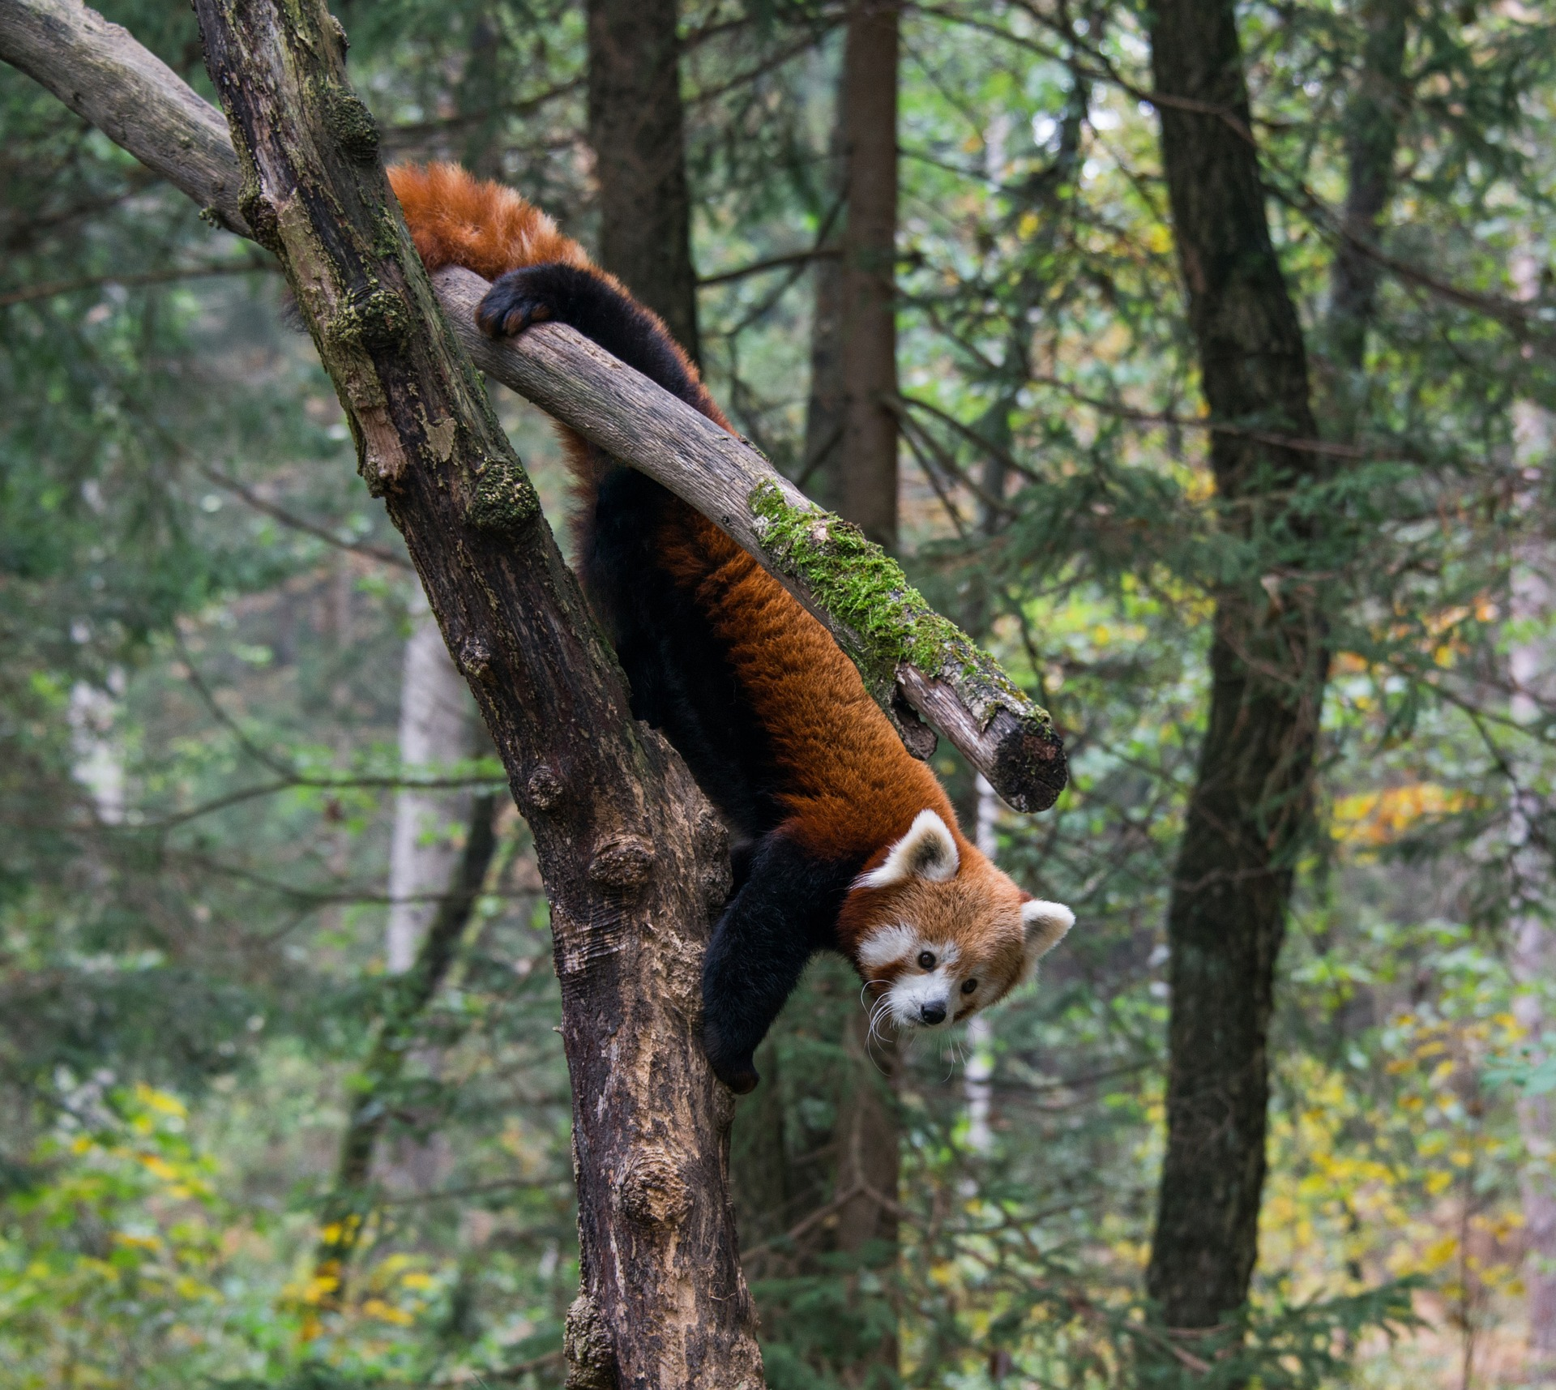Expanding human populations are encroaching into a range of habitats, increasing the magnitude of ecosystem modification. Land use change and habitat fragmentation have the largest impact on mammal populations, causing more change globally than hunting. Arboreal mammals with narrowly defined niches and low dispersal capabilities, such as the red panda, are the most susceptible to population declines following habitat disturbance. Quantifying and mapping habitat changes is key for informing conservation efforts for these sensitive species. The remote Himalayan range of the red panda makes remote sensing the most viable option for evaluating large scale habitat change caused by the increasing human population within panda habitat.

Figure 1: A

The red panda

The red panda (*alirus fulgens*) is an endangered mammal found between 1000, and 5000 m in hillside forests with bamboo understory. Red pandas are exacting in their habitat requirements and prefer undisturbed habitats with over 30% forest and bamboo cover. Red pandas are omnivores but subsist almost exclusively on bamboo 98% of their diet being from bamboo. Red pandas are predominantly solitary and exist at low densities (1 panda per 4km2). The red panda composes its own unique tanxnomix family. Two genetically distinct populations of red pandas exist, separated by the Nujiang river valley. Whether these two populations represent two distinct species is still an area of active research. Even tho

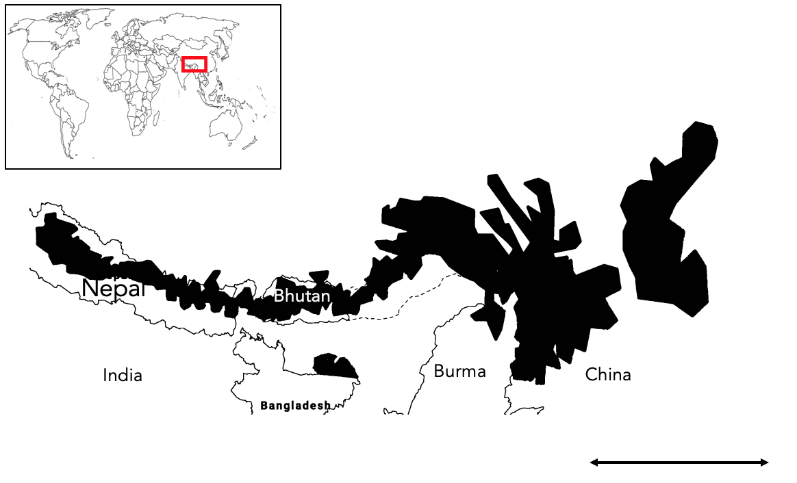

This once obscure mammal is now receiving more public attention, yet conservation efforts for the species lag significantly behind the more famous Giant Panda and other high-altitude species such as the Himalayan musk deer (Moschus leucogaster), with many aspects of red panda ecology and distribution still unknown. The population of red pandas is feared to have declined by 50% over the last three generations, raising concerns about the species extinction. Precise population trends are unknown due the sparse number of red panda records across its range. Red Pandas are most well documented in Nepal and Sichuan China, yet even here most information comes from indirect signs such as scat and pug marks. Where populations are studies, there are found in clustered pockets of habitat away from human disturbance and close to water and bamboo thickets.

Low density and mainly solitary/ Fecundity/ movement patterns? Three known isolated populations. Diet

Economic opportunities for people in Red panda habitat are limited and are often based around harvesting natural resources, which tends to damage panda habitat. Small scale timber harvesting for firewood and building, and clearing for agriculture and grazing are the dominant mechanism for forest loss in panda habitat.

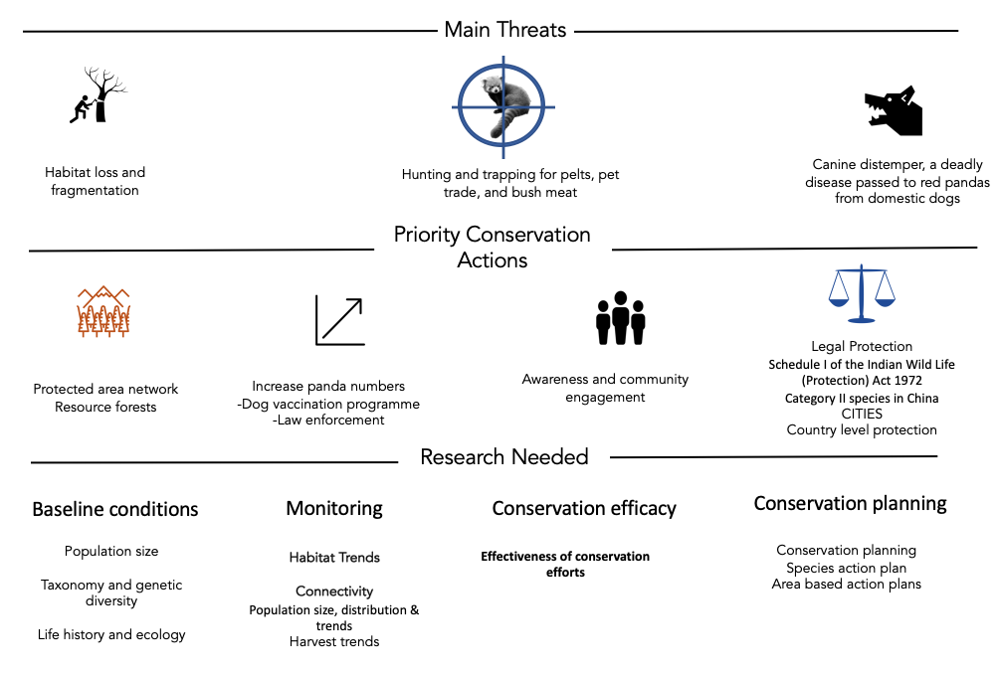Local action. Wide scale measures are not red panda specific. No coordinated range wide management plan exists. I have found it suspiring that there is not more research and conservation interest for the red panda, considering it is cute af. The species primarily suffers from lack of research due to remote distribution, however much of its habitat is now accessible.

Habitat loss is consistently stated in the literature as the largest threat facing red pandas.

1.3 Project Rationale

Knowledge gap. There is a want to develop a range wide transboundary conservation plan for red pandas. This involves:

* identifying the core and most threatened bits of habitat
* Is habitat being lost, if so where
* Is the rate of loss increasing?
* Is the habitat connected? Are there at risk bottle necks
* How are pandas doing in different countries
* Is the protected area network sufficient and how should we protect habitat (corridors like tigers?)

We currently don’t know the big picture of how forest cover is changing. This could lead us to protect the wrong areas or invest resources in inefficient ways. Many of these questions can be answered by pre-existing remote sensing datasets. By using a forest loss dataset from Hansen, I want to explore what change is happening to red panda forests and where change is happing. I think this would be valuable to conservation decision making process for red pandas. Knowing hotspots of loss and how different areas are changing habitat. Indeed, the IUCN small carnivore group has identified habitat monitoring as the highest priority research topic for red pandas. Small scale habitat monitoring plots in Western Nepal but I is simply not known what is happing at the rage level. We already know there is insufficient protected area coverage for red pandas, and there are calls to establish new areas to protect pandas. This assumes current pa’s are working for pandas. I am also interested in seeing if this appears to be the case.

A MaxEnt distribution model for Red Pandas was created in 2018 to help identify where important habitat is. The tight niche of red pandas allows for the reasonable assumption that forest cover represents panda habitat. Doesn’t detect understory bamboo but hey ho. I have made a red panda specific resource and have looked at broad scale patterns.

A remote sensing approach

Large datasets require large processing power to create and analyse. The creation of cloud based spatial analysis such as the Google Earth Engine in 2013, provide a free platform to conduct analysis on big spatial data. Hansen is appropriate for a first assessment of forest change. Good resolution and accuracy for the size or area being looked at too. There is precedent for this approach too. Tiger priority areas have been monitored with this dataset.

In this dissertation, I use publically available forest cover change dataset to evaluate what changing is happening to forest in red panda habitat and identify where this change is happening. Comparisons will be made between conservation relevant areas of interest to gauge large scale trends in the pattern of loss. A map of loss has also been created to qualitatively explore finer scale patterns and provide local information for conservation planning. These results provide

1.4 Research questions and hypotheses

What change has occurred to forests in red panda habitat?

Due to the emphasis put on threat of habitat in the literature I expect a sizable about of forest to have been lost across this entire range. The value of 10% has been chosen arbitrarily to represent a sizable amount of loss. I also expect the rate of forest loss to be increasing as the human population in increasing in red panda habitat. I expect the rate of loss to be increasing linearly as this broadly corresponds with the rate of human expansion in the region. If my predicted amount and rate of forest loss is found, it will provide evidence of the urgency of conservation efforts for the red pandas and could contribute to the reclassification of protection level in China and inform IUCN red list assessments.

H1: The area of forest in red panda habitat has decreased by 10% from 2000 to 2018 across the entire range.

H0:

Ha:

H2: The rate of forest loss has increased in red panda habitat from 2000 to 2018 across the entire range.

H0:

Ha:

Where has forest been lost in red panda habitat?

It is expected that the proportion of forest loss will differ across red panda range. Different countries have varying land management strategies and intensity of resource use. For example, Bhutan is expected to show the lowest proportion of forest loss due to its relatively low population whereas china is expected to show the highest forest loss. Across the entire range forest loss is expected to be higher at lower elevations because of the easier access to humans. Core areas are expected to lose the most forest out of every habitat class as these areas tend to have the best timber and bamboo resources, hence will be targeted more for resource extraction. IUCN obvs. If these predictions are supported, it will the broadly indicate the most impacted and threatened areas and can help identify possible reasons for forest loss i.e. people driven with elevations, protection, and country populations, and resource driven with the core areas. The full map will show finer forest loss detail and help identify specific areas of substantial forest loss and areas of un disturbed forest.

H1: Different countries have lost different proportions of forest cover in red panda habitat.

H0:

Ha:

H2: Lower elevations were correlated with higher proportions of forest loss

H0:

Ha:

H3: Core areas of habitat have seen the highest proportion forest loss

H0:

Ha:

H4: Higher IUCN ratings have lost the least proportion forest compared to lower IUCN ratings and unprotected areas.

H0:

Ha:

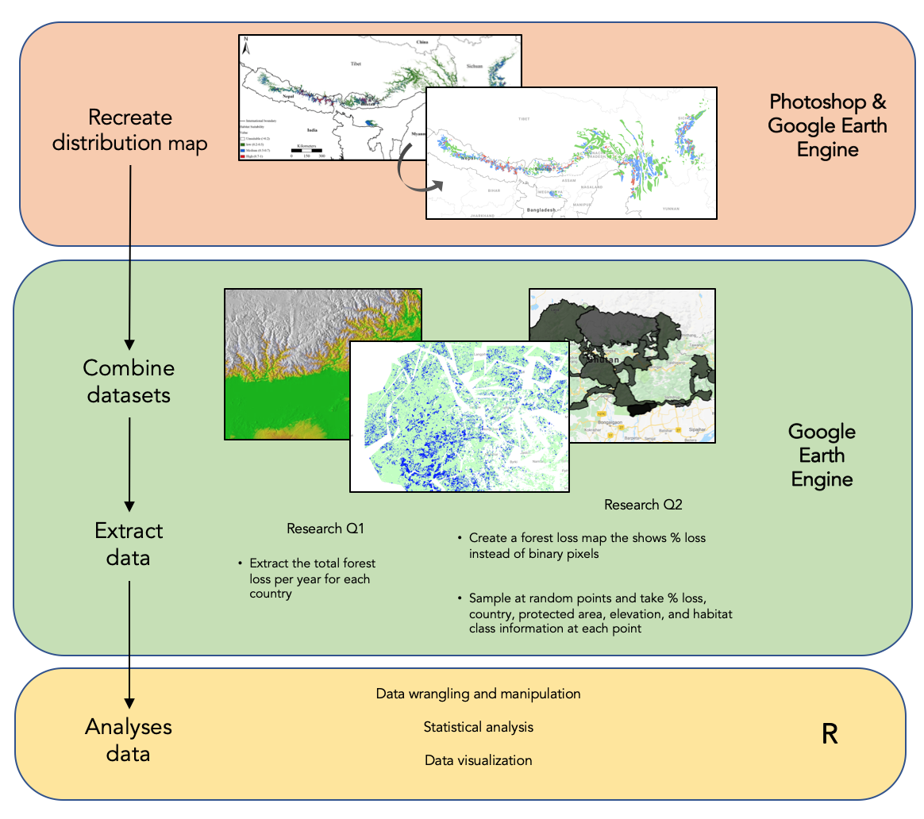2. Methods

Defining the study area

The best data on red panda distributions comes from a 2018 MaxEnt model. The model used climactic, terrain, and weather variables alongside location records of red pandas to create the distribution. The accuracy of XX was stated by the authors and I am comfortable that the map represents the true panda distribution well. I have conducted my analysis within the regions defined by this study. Three habitat classes were mapped: Low 20-40%, Moderate, and Core. I used Photoshop to remap the distribution map onto the base layer of google earth engine, in effect geo-referencing the image by hand using country borders as control points. Polygons were then created on GEE to represent the different habitat classes. This will have resulted in the miss mapping of some panda habitat. However, visual assessment of my map shows good coverage of likely habitat. I further refined this map by clipping the image to >20% forest cover to better reflect red panda habitat.

2.2 Data collection

Datasets

All data used in this dissertation came from pre-existing and publically available geospatial datasets detailed in table 1. Each dataset was imported into the google earth engine and had been pre-georeferenced.

The Hansen forest loss data was processed from Landsat imagery and classes any vegetation over 5m in height as a forest. This definition is used my me in this dissertation. Loss was only recorded if the entire pixel transitions from forest to no forest, with gain being the inverse. Forest gain was only available as a cumulative layer up to 2013. The algorithm used to process the landsat imagery was recently updated by Hansen et al to better detect small scale forest loss from 2013 – 2018.

|  |  |  |
| --- | --- | --- |
| Dataset | Source | Description |
| Hansen V1.6 |  | The image gives a binary layer for loss no loss for 2000 – 2018 (each a separate band) and a cumulative image for the entire range. It |
| Elevation |  |  |
| WDPA |  |  |
| Country polygons |  |  |

Analysis in the Earth Engine

All analysis was conducted using the native scale of the gfc dataset. For all loss data, the image(s) were clipped to >20% forest cover measured at 2000 to better reflect panda habitat.

RQ1

Yearly forest loss bands were selected and grouped together using ee.Group.

A reducer function was then used to sum the loss pixel for each country

Code snippet?

**RQ2**

Creating the forest loss map

I transformed the binary Hansen forest loss data into a map where each pixel represents the average forest loss within 1km2 buffer. I did this for two reasons: i) It is easier to visualise the data and see areas of high forest disturbance and ii) It provides more information on the magnitude of loss at a sample site. A mean neighbourhood circular kernel was used to convolve the image.

I created my own image collection merging the forest loss map, country data, elevation, pa coverage, and habitat class. Every data from a table was transformed into an image by clipping a land mask to its bounds.

In order to gauge the variation in forest loss within areas of interest, I used a sample based approach. 5000 random samples were taken by reducing over randPoints. This number was deemed to be the maximum number of samples without significant overlapping of sample counts, reducing double counting.

2.3 Data processing

The outputs of the earth engine scripts were export as CSV files and loaded into excel for first data cleaning. levels merged into one column and accessory and unwanted metadata for each file was removed.

in excel and then imported into R

% calculation

filtering to get rid of samples in areas less than <20% forest and in any overlapping habitat classes caused by me being a dumbass and not drawing my polygons well.

2.4 Data analysis

Statistical Models

R version alpha = 0.05

All models were planned a priori, and to have biological relevance. No model comparisons have been made as each model is designed for a specific research question. Data distributions and residual fits were visually assessed using qqplots and histograms. A linear model was used for RQ1 and nonparametric analysis was conducted for RQ2 due to the major violations of assumptions of the data (zero inflated and non-normal). Kruskal wails tests were used to compare means. This test was chosen because the distribution of forest loss values was the same shape in every group. Post hoc analysis using the kruskalmc function in pgirmess was done to identify significantly different means whilst also accounting for multiple comparisons, this is analogous to the parametric tukey HSD test.

Statistical approach. A priori model creation, biological relevance.

3. Results

What change has occurred to forests in red panda habitat?

The rate of forest loss in red panda habitat has not significantly increased across the entire range from 2000-2018 (linear model, slope = 0.0014 ± SE 0.0013, Fstatistic = 1.204, DF = 16, adjusted R2= 0.012, P = 0.288). At the country level, India and Burma were the only countries that showed a significant increase in the amount of forest lost between 2000-2018 (Table A1, Appendix). A total forest loss of 1.3% (1753 km2) was found across the entire range. At the year 2013, 0.169 % (227 km2) of lost forest had regrown.

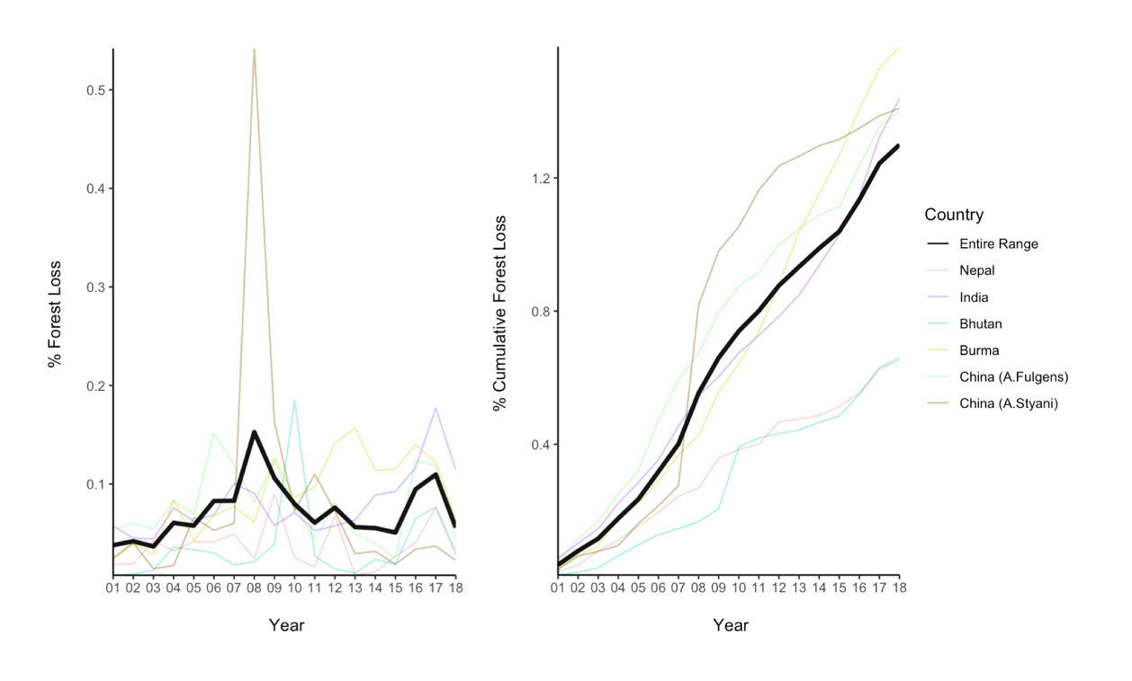**Figure 5: Total forest cover has changed in red panda habitat from 2000 – 2018.** A) B) Total area of habitat 134880 km2

here has forest been lost in red panda habitat?

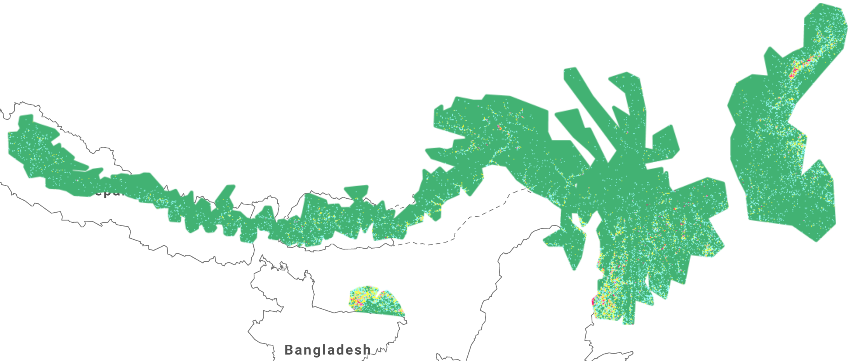Habitat loss in red panda habitat is clustered and not uniform across the range. A visual assessment of the location of loss showed that forest loss was usually found close to roads and human settlements.

**Figure 6: Map of forest loss in Red Panda habitat.**

Different proportions of forest were lost in each country (Kruskal-Wallis, χ2 = 69.256, df = 5 , p-value 1.463e-13). This is in support of H3 with china showing the highest average forest loss and Bhutan and Nepal showing lower loss.

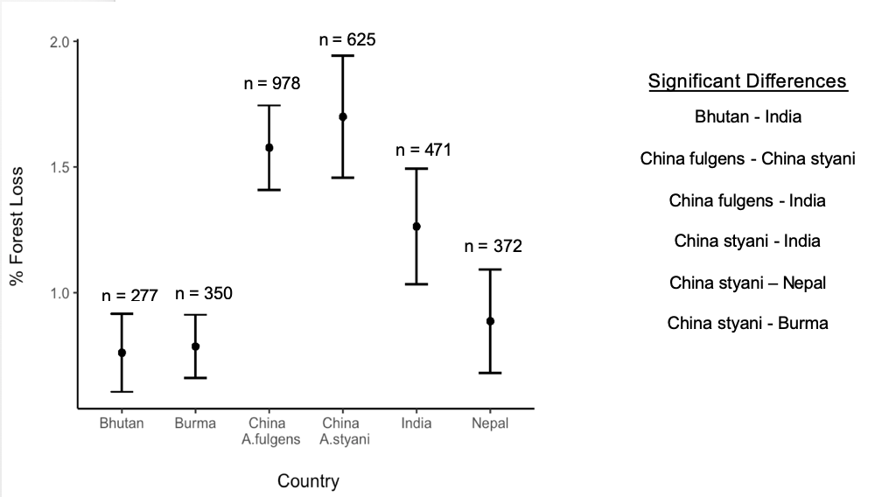

Figure 4

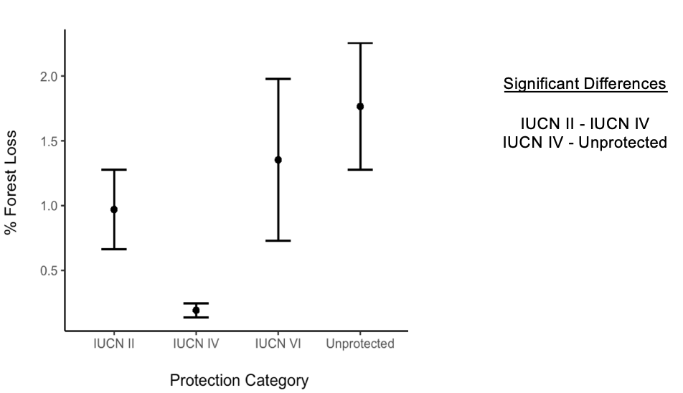Different proportions of forest were lost in areas with different protection (Kruskal-Wallis, χ2 = 16.108, df = 3, p-value 0.001078).

Figure 5

Different proportions of forest were lost in different habitat classes (Kruskal-Wallis, χ2 = 13.753, df = 2 , p-value 0.001032). 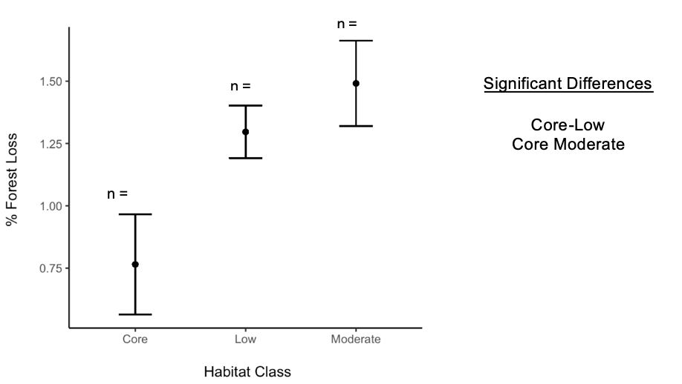

A significant relationship was found between the proportion forest loss and elevation with lower elevations lossing around 4 time more forest (Spearman Correlation, rho = -0.1506997, n = , p-value < 2.2e-16).

4. Discussion (Demonstrate Understanding!)

Key findings

2-4 points

Highlight what wasn’t known before

Rate of forest loss not increasing. Temporal autocorrelation is not accounted for would serve to increase rate of slope. Time means more people means more loss

4.1 How is Red Panda Habitat changing?

How do these results compare to on the ground studies?

Forest loss vs habitat degradation. Up loss by 30% +/-20%.

4.2 Conservation implications

Protected areas show signs of working

All habitat seems to be connected but there is loss high up the mountains too. Sympatric conservation, pool resources and identify key corridors.

4.3 Limitations

What needs to be considered when interpreting my results?

PA analysis should look at where loss is occurring. Not just absolute values as these are low.

Map may over estimate habitat as occurrence records are few and far between. Makes the forest loss analysis less specific to rps and may miss more relevant dynamics. Conducting this analysis in areas defined by local experts would produce a more panda relevant map.

IUCN classes run different in different countries

My methods only quantify loss between 2000 and 2018. Any deforestation before then is not accounted for in my analysis. Visual assessment showed that there were pre-cleared areas, particularly around settlements.

Slightly Unbalanced designs should be ok.

Due to the nature of my data, I had to rely on non-parametric tests in RQ2. Due to the large number of 0 values (no forest loss) across every group, there were many tied ranks. The standard process of averaging tied ranks was done. This resulted in a conservative estimate of significance (lowering the power) and a reduced the type 1 error rate. Kruskal Wallis test also compare the differences in the median value of groups, not the average that figures 6-9 show. If different groups have large difference in the number of tied ranks, the median values can be offset, further lowering the power of the test. A combination of these factors likely resulted in the unusual significant differences, with the apparently similar China A.fulgens and China A.styani being significantly different yet the apparently different Bhutan and China A.fulgens showing no significant difference. If I had more time I would look into models that explicitly deal with non-integer zero inflated data, potentially a quasi-poission mixed effect model or a two part hurdle model. Spatial auto correlation is an issue. I attempted to account for this my adding longitude as a random effect in a mixed model, but due to the major assumption violations, this was not possible.

4.4 Future work

What else should happen in order to design an effective range wide strategy for red pandas? Need to confirm species occurrence. Camera trapping programme

Quantify fragmentation impacts

Panda density estimates

This will work towards identifying connectivity across the range

Sympatric conservation too with Tiger conservation, Mishmi Tackin and other species of conservation concern. Large overlapping habitat.

Active remote sensing could be used key panda areas to monitor change to the structure of the vegetation and

Forest loss to gain has only been calculated for the entire range. I would explore how gain changed too.

5. Conclusion

The proportion of forest lost between 20002018 was substantially less than expected

6. References

7. Appendices

Country level breakdown of forest loss rate

India = linear model, slope = 0.004089 ± SE 0.001146, F1,16 = 12.74, P = 0.002563, DF = 16, adjusted R2= 0.4084

8. Text junk yard

Get [Outlook for iOS](https://aka.ms/o0ukef)

_____________________________  
From: Isla Myers-Smith <[isla.myers-smith@ed.ac.uk](mailto:isla.myers-smith@ed.ac.uk)>  
Sent: Thursday, March 9, 2017 6:51 pm  
Subject: How to report statistical results - for dissertation students and other interested folks!  
To: Team Shrub Edinburgh <[teamshrubedinburgh@mlist.is.ed.ac.uk](mailto:teamshrubedinburgh@mlist.is.ed.ac.uk)>

Hi Team Shrub dissertation students and others,

I was having a chat with Arabella about how to report statistical analyses in your dissertation and I put together some examples for my own work to demonstrate best practice (hopefully!).  You can also present results in tables or figures.  And it depends a bit on the statistical result how you might report things, but here are some examples.  There is no hard and fast rule, but in general it is better err on the side of more information rather than less and at a minimum you should aim to include: 1) The name of the test, 2) the effect size and error (e.g., slope ± SE), 3) the test statistic (e.g., F statistic, t-value, etc.), 4) the sample size or degrees of freedom, 5) the p-value, 6) the model fit (e.g., R2).  Is there anything I am forgetting?  If I could only have one set of numbers it would be the effect size and error, but remember more information is usually better!

Qikiqtaruk manuscript folks - we are not following best practices at the moment, so we need to go back in and add all of the missing information into our text!!!

Isla

ANOVA:

"No differences were observed in height of the three most commonly surveyed species (ANOVA, F2,224 = 1.39, P = 0.25); however, patch sizes were larger for S. pulchra (ANOVA, F2,224 = 8.61, P < 0.01, Tukey's Test pair-wise comparisons)."

Linear Regression:

"The climate sensitivity of stems to both July temperature (linear model, F1,90 = 2.927, P = 0.091) and March precipitation (linear model, F1,88 = 1.624, P = 0.206) was not explained by the climate sensitivity of their root collar counterparts."

- We should have included the slope ± SE as well probably!

Kruskal-Wallis test and MANOVA:

"Age among all willow species surveyed did not differ significantly (Kruskal-Wallis, χ2 = 60.74, df = 51,*P* = 0.17). Patch sizes, measured as both width and height, varied between species (MANOVA, Pillai's trace = 0.25,*F*10,564 = 7.91, *P* < 0.01)."

Linear mixed model:

"Willows were smaller at shrubline relative to those at lower elevations (Table S2, linear mixed models, shrubline estimate ± SE = -0.44 ± 0.06, t-value = -7.39,*P* < 0.01)."

-- Isla H. Myers-SmithSchool of GeoSciences, University of Edinburgh113 Crew Building, The King's BuildingsWest Mains Road, Edinburgh EH9 3FFphone: +44 (0) 131 650 7251e-mail: [isla.myers-smith@ed.ac.uk](mailto:isla.myers-smith@ed.ac.uk)<http://teamshrub.wordpress.com/>